**PUBLISHER MODEL**

If you work for a books company, then you have to deal with publishers, authors and the transaction which happens between them. Here we have some tables from that domain.

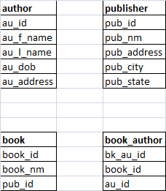

1. Identify the relationships between each table.
2. Query to get the number of books by each publisher.
3. Write a query which gives book_name, author_name for publisher ‘XYZ’
4. Which book was written by more than 3 authors?
5. Want to include city and state information of author as well in the model. So, modifiy the model and show us the new model what you come up with.
6. Display publisher name, pub_city and metro flag of the city. If city is CHN or MUM or DEL or CAL then display the flag as ‘Y’ otherwise ‘N’
7. Display the authors whose age is greater than the author ‘RAM KUMAR’
8. Display the publisher name, author_name and no of books they wrote.
9. Which author wrote the maximum number of books?
10. Create a stored procedure which returns book_name, author_full_name by taking publisher name as the input.
11. Take the publisher name as input and give the number of books which that publisher published where there are only one author.